ĐỀ THI TIẾNG ANH Mã đề: 04
Trình độ A2
Họ và tên thí sinh: ……………..……………………………………………………….…………………………………………………………
Số báo danh: ……………..…………………………………………...……. Phòng thi số: …………………………….……………

PAPER TWO LISTENING (Approximately 15 minutes)
PART 1: Questions 1 – 5
There are five questions in this part. For each question there are three answer choices and a short recording. Tick (√) the correct answer. You will hear the piece twice.
Example: How many people were at the meeting?
A. 3 B. 13 √ C. 30
1. When did Gary start his new job?
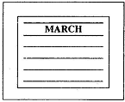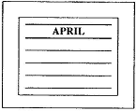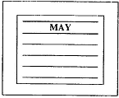
A □ B □ C □
2. What time does the film start?
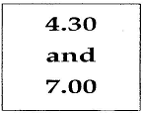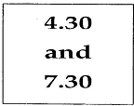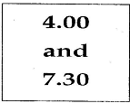
A □ B □ C □
3. What was the weather like on Saturday?
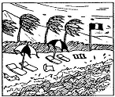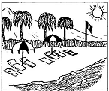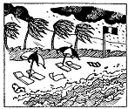
A □ B □ C □
4. Which motorway will they take?
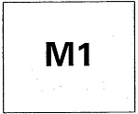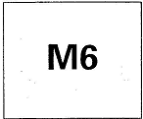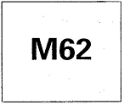
A □ B □ C □
5. Which book does Lorna want?
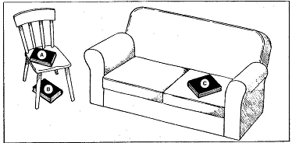
A □ B □ C □
PART 2: Questions 6-10
Listen to Sonya talking to Martin about her family. How old are her brothers and sisters?
For questions 6-10, write a letter A-H next to each person. You will hear the conversation twice.

EXAMPLE | ANSWER
0 Sonya | H
PEOPLE |  | AGES
6 Sally  7 Vivienne  8 Roger  9 Frank  10 Deborah |  | A two  B five  C seven  D ten  E thirteen  F fifteen  G eighteen  H twenty

PART 3: Questions 11-15
Listen to Jan talking to Steve about getting a student travel card.
For questions 11-15, tick (√) A, B, or C. You will hear the conversation twice.
Example: 0. How is Steve going to London?
A. by bus
B. by car
√ C. by train
11. How much is a travel card?
A. £6
B. £16
C. £60
12. Jan will need
A. one photo
B. two photos
C. four photos
13. Photos are less expensive
A. in the photographer’s shop
B. in the library
C. in the post office
14. For the travel card, Jan must take
A. a letter
B. her passport
C. her driving license
15. Jan can get a travel card from
A. her college
B. the travel agent’s
C. the tourist office

